
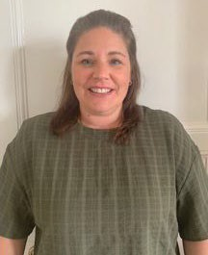


The 5 Day Offer
Rachel Maulkinson

Hello!! I am your ‘5 Day Offer Officer’ for the Wakefield Local Authority.
My role is to support young people with special educational needs and disabilities (SEND) aged 16- 25, who have an ‘Education Health and Care Plan’.

The ‘5 Day Offer’ supplements what young people receive in their current education setting.

The role of the 5 Day Officer is to support young people outside of their education settings, for a maximum of 6 months, through targeted work. I will support young people to access provision that includes volunteering or community participation and work experience opportunities that will enable young people with a skillset needed to make a successful transition to adulthood.

I can help young people identify further meaningful activities in line with their interests and aspirations that can be undertaken with or without support in and around the area they reside in, if they are prepared to engage with this process.

My role involves developing operational links with other agencies to enable effective inter-agency working, in particular local schools, colleges, education, training and employment providers. I will signpost, guide, and provide support to access information to help young people feel less socially isolated and included within their community.

(Please be aware, if the young person requires 1:1 support whilst undertaking an identified opportunity, we may need to be creative and use their short breaks/current Personal Assistant support or Adult Social Care funding to support that activity moving forward).

Many of the young people I work with, become more confident engaging in employment opportunities Post 18, and this is due to their increased self-esteem because of being able to upskill and participate in work experience/placement opportunities.

If you would like my help, please feel free to complete the ‘5 Day Offer’ referral form that can be found on the Local Offer and send it to SENDPFA@wakefield.gov.uk


